­­ **BIMTECH Partnered for Erasmus Mundus Project with FH Joanneum Austria**

**UNIQUE- University Quality Exchange**



UNIQUE is a Erasmus Mundus funded project which is aimed at improving services for international students, address the international dimensions of Quality Assurance and to promote the joint programmes towards students. The consortium members include FH Joanneum, Austria; World University Service, Austria; Universida de Alicante, Spain; Voronezh State University, Russia; Univeristy of International Business and Economics, China; Intstituto Technologico de Monterey, Mexico; Birla Institute of Management Technology, India; Polytechnic of Namibia, Namibia; Aston University, UK.

The UNIQUE project will collect and disseminate information on European higher education with focus on quality control including Bologna process, competence based teaching approach, ECTS etc. The project will do a thorough needs analysis in the five non-European partner universities to identify the knowledge available and knowledge gap for a better cooperation with European universities. The project will install UNIQUE centres in universities in China, India, Russia, Mexico and Namibia which will act as regional hubs spreading project ides through the region.

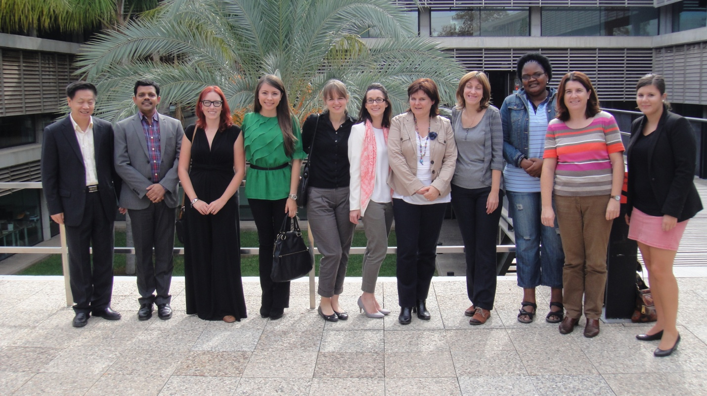

The project kick off meeting was held at Universidad de Alicante, Spain in October 2013. In the current phase of the 2.5 years project plan, BIMTECH is actively involved in the knowledge pool creation, focus group and experts survey and local needs analysis. Over the course of next months, BIMTECH along with a European partner would implement UNIQUE centre activities, and conduct local training seminars for knowledge dissemination in the region.



Source: BIMTECH Newsletter APRIL14 to JUNE 2014

Contact: Prof. Rahul Singh: [rahul.singh@bimtech.ac.in](mailto:rahul.singh@bimtech.ac.in)