|  |  |
| --- | --- |
|  |  |

**UNIQUE Centre @ BIMTECH**

**Idea Workshop, October 10, 2014**

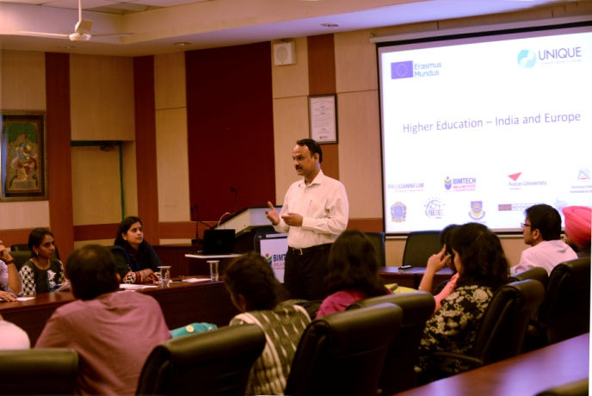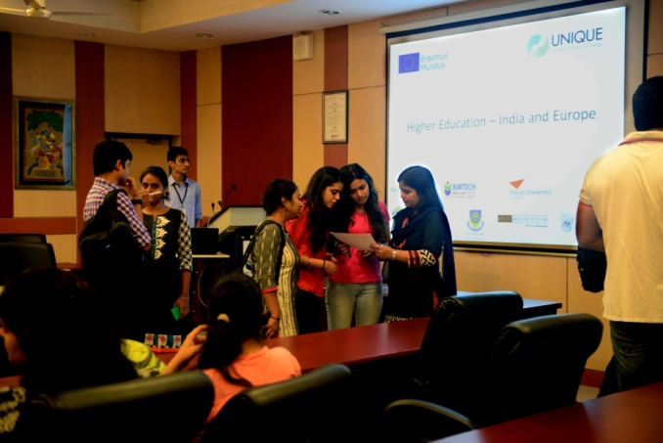

A detailed discussion was held with students of BIMTECH to find out their expectation from UNIQUE Center. The workshop began with introduction of UNIQUE project and its objectives. Students were explained the benefits of stating UNIQUE Center and how it will facilitate the outward movement of students.

Students were then asked to mention the type of information that they want for going on a exchange program or other master level program.

**The Unique Project**

1. Promoting the idea of *international collaboration and exchange*

2) Promoting *quality in higher education* in the beneficiary countries´ in order to be directly comparable with European standards and support the university management in its introduction or adaptation

3) *Defining, collecting and analysing key performance indicators* (KPI) which are comparable to those from European universities

4) *Counselling the home university concerning recognition of European courses, grades and admission* of incoming European students.

5) *Counselling international offices and outgoing students in selecting high quality European institutions* for their studies

6) *Screen the European higher education area* for new developments.

**Workshop for UNIQUE Centre**

The project will install centres in five different Universities in China, India, Russia, Mexico and Namibia. In India, UNIQUE centre will be installed at BIMTECH. For which a workshop was organized to explore ideas for the UNIQUE centre where students expressed their views and expectations from the proposed Centre. These issues will help the Centre and the administrators in devising and administering the marketing plan.

The queries were raised by students for them to successfully plan, prepare for and study at a European University.

Following are issues, which students felt are important and would want UNIQUE center to provide information on.

* BIMTECH has credit system and the partner university has ECTS. What is the equivalence between the two systems since this will decide how many courses they need to study under the exchange program
* What courses should they take at the partner university? What university should I choose for my area of interest i.e. marketing/ finance/ HR/ operations/ international business
* How do I choose a partner university?
* What kind and how much expenses will I incur for going under exchange program?
* Is there any scholarship available for students going under exchange program?
* What kind of formalities are required to be completed at the partner university once we have been nominated by BIMTECH?
* Travel arrangements
  + Visa process
  + Flight
  + Insurance
* What kind of facilities are available for students in the host country? Can exchange students avail those facilities?
* How to make accommodation arrangement at the partner university? How much will it cost?
* Can exchange students take up an industry project or internship in host country to augment their learning?
* What kind of challenges does the language pose while at the host university and country ?
* What are the internship or job opportunities in the host country?
* How will student exchange help me in my career?
* In addition to the academic experience, how will the exchange program help me?
* What if the term at partner university does not match with term at BIMTECH i.e. term at partner starting late and ending late? Can I still go to that university?
* Will we be part of partner’s alumni network where I studied the term?

Contact: Prof. Rahul Singh : [rahul.singh@bimtech.ac.in](mailto:rahul.singh@bimtech.ac.in)

 