UNIQUE Project and Centre @BIMTECH, INDIA
29-30 June 2015

UNIQUE – University Quality Exchange is European Union funded project to assess the quality assurance issues in 6 sub-continents. There are 9 institutions participating in the project that include 3 universities from Europe, 1 academic research agency and 5 universities from India, China, Mexico, Russia, and Namibia. The research objective is to promote the idea of international collaboration and exchange, promoting quality in higher education in the participating countries in order to be directly comparable with European standards and support the university quality management in aligning the globalization, defining, collecting and analyzing key performance indicators (KPI) which are comparable to those from European universities, and creating a UNIQUE centre in each partner university to host the knowledge created in the project and counsel other universities and institutions in the country on programs and systems of European or other partner nations.

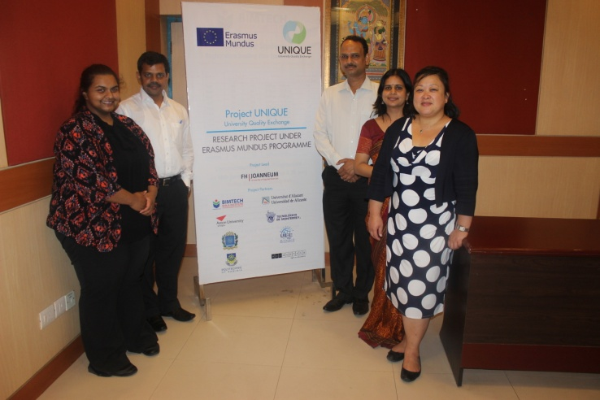 | 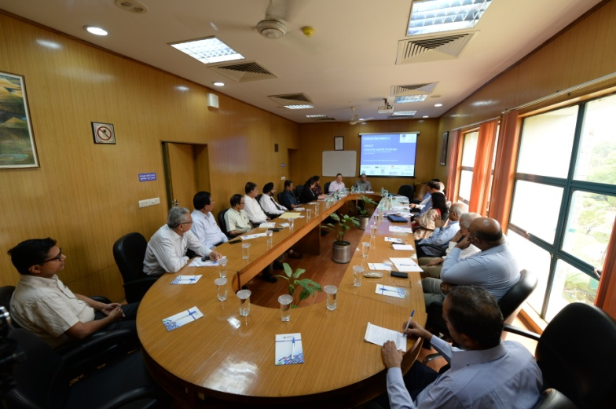

BIMTECH has Aston University as its mentor partner on UNIQUE Centre and quality assessment issues. Ms Wendy Yip, Director International Developments and Dr Rebecca Aggarwal visited from Aston University for 2 days project mentoring and meeting. Sessions and discussions were designed to help the quality process and systems learning about European Bologna, UNIQUE Centre, Internationalization of EU universities and other accreditation systems.

Since one of the main objectives of the project is dissemination of the knowledge created and building a discussion in the national university and policy circle, BIMTECH organized a half day seminar on ‘Internationalization of Higher Education and Quality Assurance’ in partnership with Education Promotion Society for India (EPSI). This seminar was participated by almost 56 academics and university leaders like rectors, Deans, Directors and professors from many parts of India. The seminar presented details of the UNIQUE project and UNIQUE centre to the audience from outside and BIMTECH. The information about this seminar was disseminated by EPSI and BIMTECH on a database of more than 2000 schools and experts in different domains in higher education. This dissemination will ensure that centre is known to most of the HEIs in the higher education ecosystem which are keen in student mobility and faculty mobility.

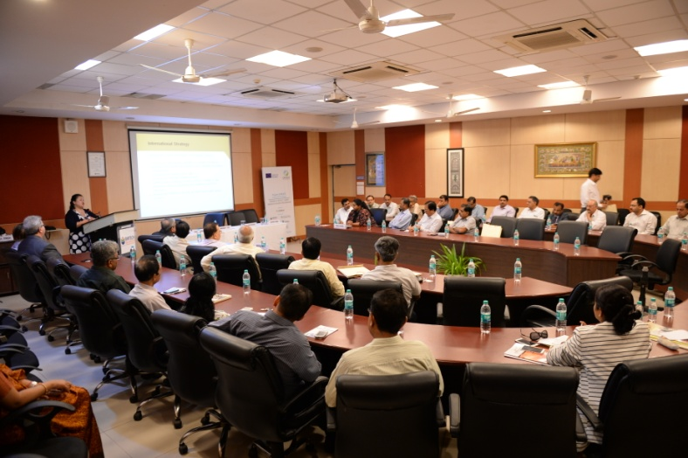 | 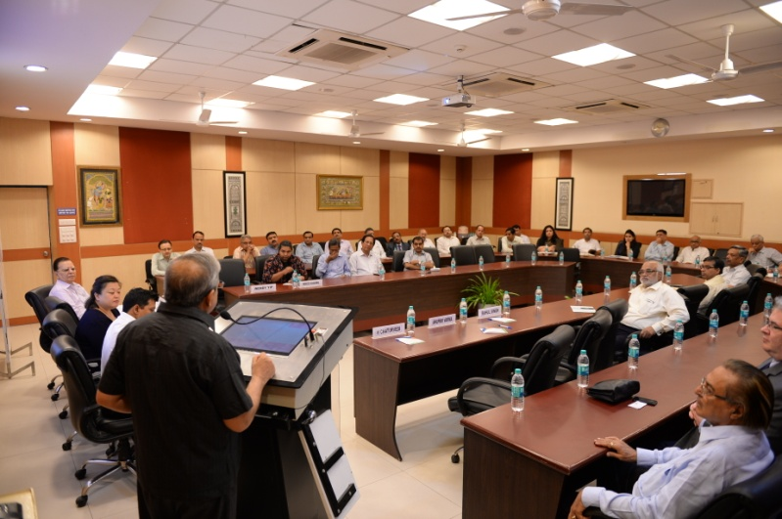

The project will end in March 2016 with 5 UNIQUE centres around the world and considerable knowledge on European and 5 sub-continents’ higher education system and knowledge of comparability. The final meeting of the project will take place in BIMTECH.

