UNIQUE Centre @ BIMTECH
Information Workshop
Student Exchange Outbound batch 2015-16
October 21, 2015
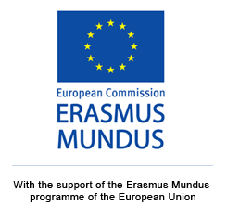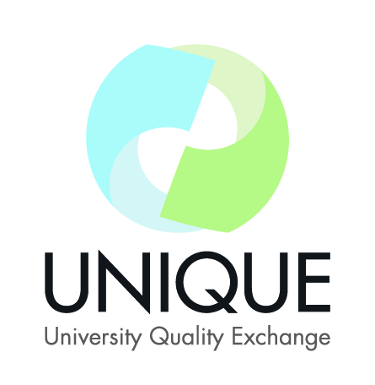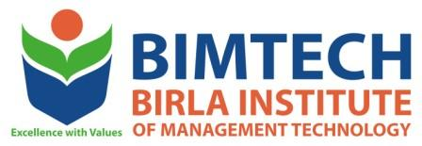

UNIQUE centre India organized its BIMTECH internal workshop on student exchange programme. The sessions was attended by students participating in the programme and the concerned officials.
Student exchange is one of the vibrant activities at BIMTECH. Over the past two months students went through the application process and were shortlisted for their preferred host institute for exchange program. The Centre for international affairs sent the nominations to respective partners. BIMTECH students will be going to partner universities- FH Joanneum Austria; IESEG Paris, Kedge BS Bordeaux, Kedge BS Marseille, France; Warsaw University, Kozmenski University, Poland; Yonsei University, South Korea; USB, South Africa;
On October 21, a pre departure workshop was organized for preparing students for academic, administrative and visa formalities before their travel to partner university. Students were briefed by international affairs team, programme chairpersons, and the UNIQUE team about course selection, credit management, internship etc. The workshop was a part of the series of sessions organized by the centre for a smooth process of exchange. Students queries were regarding credit conversion system between BIMTECH and partner university, type of courses they should study, internship opportunities in host country.

